**Breadboard instructions**

The breadboard is an experimental equipment that makes it very convenient for us to build circuits in experiments.

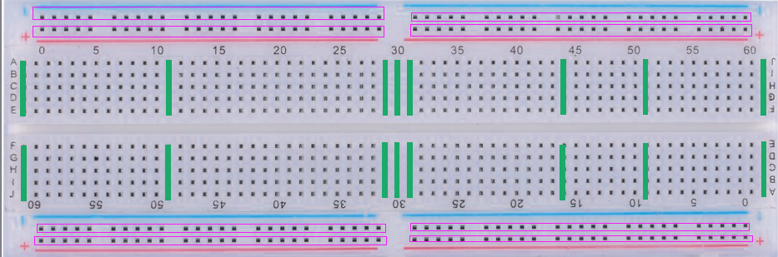

The green line and the purple box in the figure above indicate that the jacks are connected together. For example, in the red circled socket on the left side of the figure, add a 5V voltage to one of the jacks. Holes are 5V voltage

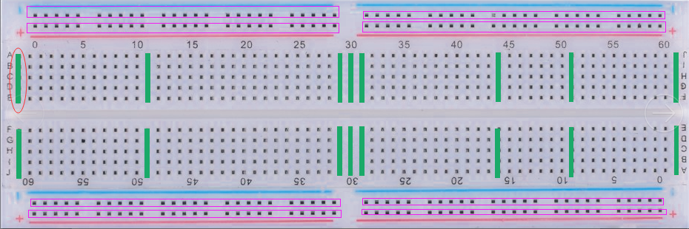

Columns and columns are not conductive, and the "+" and "-" lines are also non-conductive, as shown in the following figure.

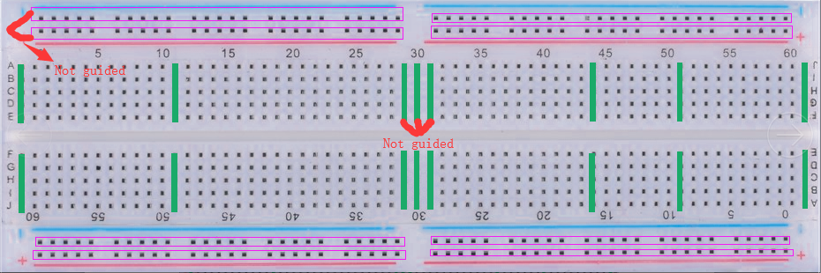

It is also important to note here that there are four power supply areas on this breadboard and they are not conductive. This is to facilitate us to do multiple experiments, as shown in the following figure.

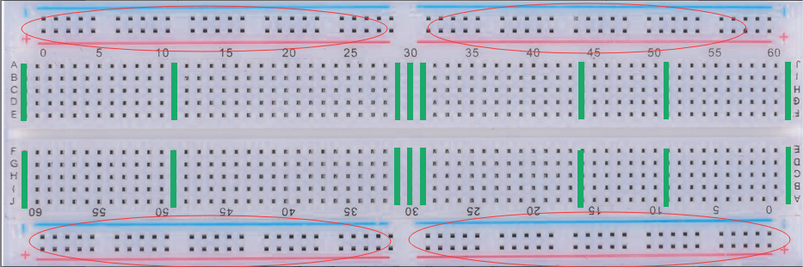

Here's an example. I chose any jack in the position of the "+" in the upper left corner, which is the purple box, and gave him 5V. At this time, all the jacks in the purple box are 5V, but There is no voltage in the black box on the right because they are not conductive. You can see that the red lines in the yellow circles are not connected, indicating that the two sides are disconnected.

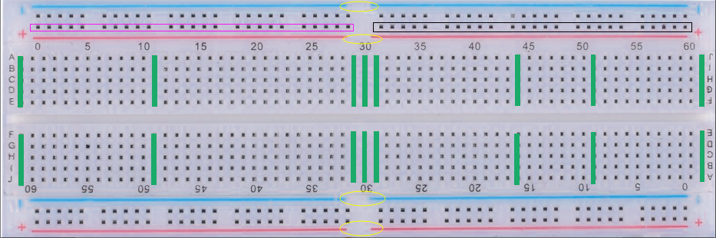

The following gives a practical example, led drive method is to join the voltage at both ends, he will light, the following is the use of 5v voltage to light it, here is pay attention to the long led led is a positive connection that is 5V voltage, short The pin is connected to GND at the negative pole. If the reversed LED is not illuminated, a resistor must be connected in series. Because the current is too high, the LED lamp is burned. The LED lamp is as shown below.

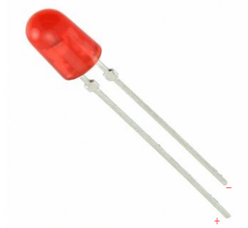

The following figure shows the preparation before the experiment. The LED and 220Ω resistors are connected in series. The Raspberry Pi 5V voltage is connected to the “+” area at the bottom right of the breadboard. GND is connected to the “-” area at the bottom right.

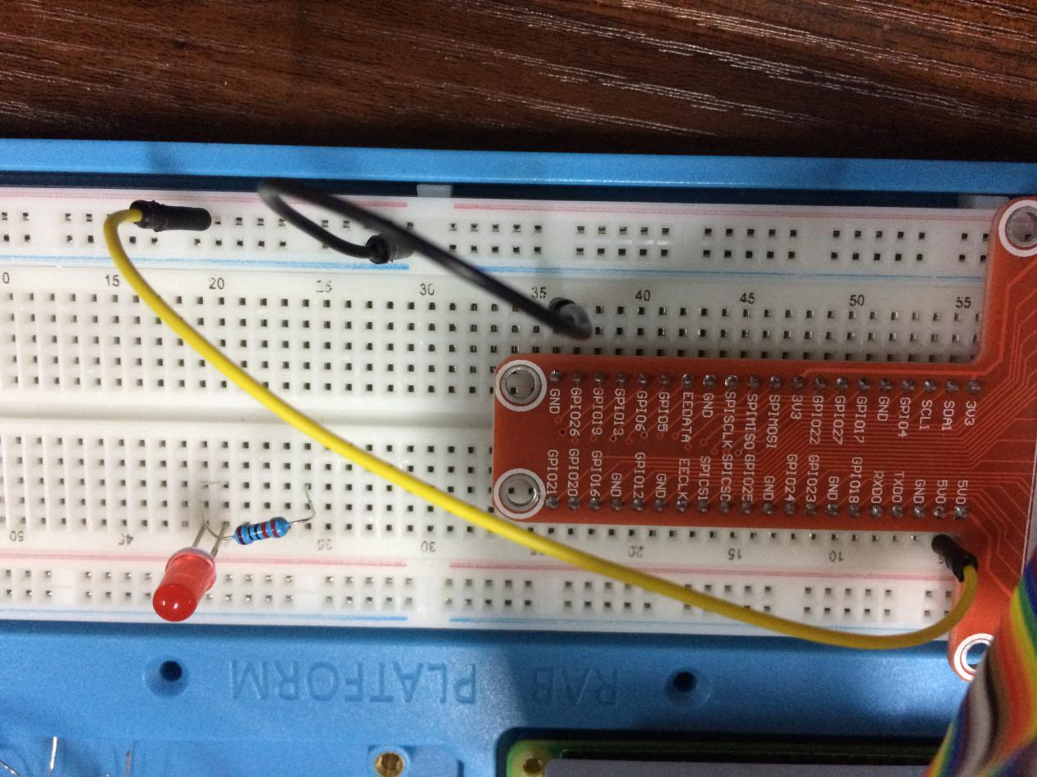

Know from the front if you add a voltage at both ends of the LED lamp, the LED will light, then according to the above, we can take a little on the “+” area of the power supply area in the lower right corner and connect it to the positive electrode of the led. The positive electrode now has a voltage of 5V. Similarly, take the “-” point of the power supply area at the lower right corner and add it to the other end of the resistor. At this time, the LED lamp will light up, as shown in the following figure:

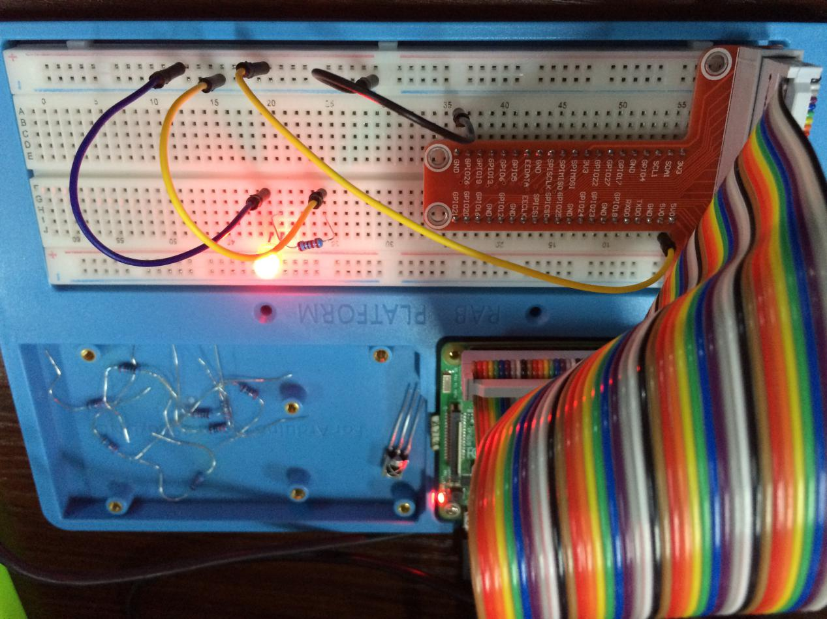

According to what I said earlier, the area is disconnected, then I will connect the GND on one end of the resistor to the "-" area in the lower left corner area, then the LED light will not light, you can notice the blue in the two areas The color line is disconnected, meaning that they are non-conductive and eventually cause the LED light to fail. As shown below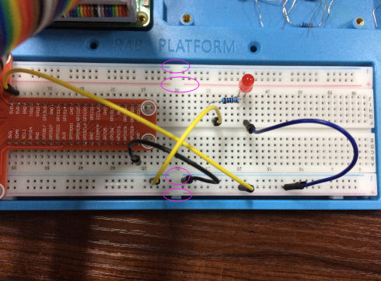

Of course, you can use a line to connect two areas, resulting in the lower left "-" area is also connected to the "GND", so that the LED is re-lighted, below I use a white line to connect two areas ,As shown below

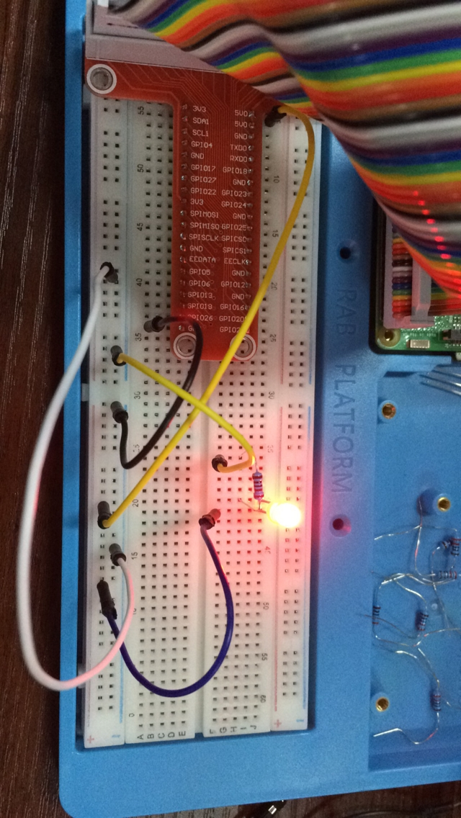

Therefore, in all the examples of our suite, you should pay attention to the wiring in the same "+" area and "-" area, otherwise you will find that the experiment will fail.